Shabbos Stories for
Parshas chukas 5781
Volume 13, Issue 43 9 Tammuz/June 19, 2021
Printed L’illuy nishmas Nechama bas R’ Noach, a”h

For a free subscription, please forward your request to keren18@juno.com
Past stories can be found on the website ShabbosStories.com

The Local Rav
And the Vilna Gaon

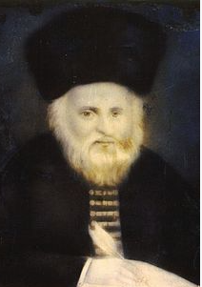

The Vilna Gaon, zt”l, held no official position in the city of Vilna. His Torah learning and advice on all areas of Yiddishkeit were sought after, however, it was widely recognized that almost all Halachic questions were directed to Rav Shmuel, zt”l, the city’s official Rav.
Once, on a Friday, shortly before Shabbos, a neighbor of the Gaon discovered a mix up of some kitchen utensils, and a question had arisen about whether the food she prepared for Shabbos was Kosher or not. Because of the late hour and her distance from Rav Shmuel’s house, instead of consulting the Rav, her husband quickly sent their son to ask the Vilna Gaon if the food was Kosher. The Vilna Gaon answered the young boy’s question and ruled that the food was not Kosher, and it was not to be eaten.

At the very same time, his wife, unaware that her husband had sent out their oldest son, quickly sent another child to the home of Rav Shmuel, the Rav of the city, to ask for a ruling on the Shabbos food. Rav Shmuel studied the issue and then ruled that the food was Kosher. The child ran home happily to report the good news.

The Conflicting Kashrus
Opinions are Revealed
It was at this point that the conflicting opinions were revealed. What were they to do? On the one hand, the local Rav had given his official ruling. Yet, who was willing to go against the ruling of the great Vilna Gaon?
Again, a child was sent, and Rav Shmuel was quickly notified of the conflicting rulings, but he reassured the family that they could eat their Shabbos meal, and the food was indeed Kosher. As soon as the child left, Rav Shmuel left his house and went to see the Vilna Gaon.
The Vilna Gaon welcomed him cordially and asked why he had come. Rav Shmuel humbly said, “You are the greatest Torah authority in the world, and I am not worthy to be the dust that you tread on. Still, I am the recognized authority on Halachah in this community, and it is not proper to have my rulings undermined and contradicted.”

The Vilna Gaon
Agrees with Rav Shmuel
The Vilna Gaon nodded his head in agreement. The Rav continued, “I therefore beg of his honor to accompany me to the neighbor’s home and partake of the food that I declared to be Kosher, although you ruled that it is not Kosher. This will clearly establish an unquestionable respect for Torah authority.”
Amazingly, the Vilna Gaon agreed to Rav Shmuel, and together they went to eat of the food that he himself ruled unfit. The Vilna Gaon submitted to the authority of the local Rav in order to make a point, that one must not argue with the rulings of our Rabbanim, or act in a way that would take away from their authority!

Reprinted from the Parshas Nasso 5781 email of Torah U’Tefilah (compiled by Rabbi Yehuda Winzelberg).
The Power of a Torah Nigun

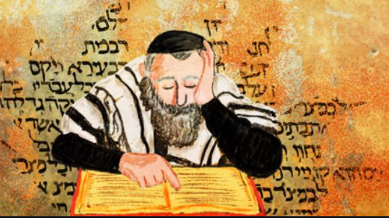

A young couple managed a healthcare facility which was home to a number of Jewish patients stricken with Alzheimer’s disease. They decided to prepare a Pesach Seder for the group. Those in the know told them that they were wasting their time. The residents were oblivious to their surroundings. These young, idealistic hosts felt that singing could overcome memory loss.
On the Seder night all the preparations had been made, and the patients wheeled in. They began the Seder by chanting Pesach melodies; the response was non-existent. Finally, they came to Dayeinu. When they began this well-known song with its generational melody, eyes opened, the residents straightened in their chairs; most tried to follow the melody and even move their lips. Music transcends time and reaches into the soul. Music can catalyse one’s return to mitzvah observance.

Victims of the Berlin Haskalah
During Horav Chaim Volozhiner’s tenure as Rosh Yeshivas Volozhin, three premier students fell prey to the pernicious winds of the Haskolah, Enlightenment Movement. The Berlin Haskalah was a powerful evil inclination that wreaked havoc on the minds of some religious men and women who were lacking in their heartfelt relationship with Yiddishkeit.
Intellectually, they were there, but the emotion which is derived either from the mussar teaching -- which allowed one to introspect into himself -- or Chassidus – which, powered by joy in mitzvah performance, added new life and vibrance to observance -- was lacking in their lives.
Each of these students excelled in a certain area. One hailed from an illustrious lineage. The second one was an extraordinary baal middos, possessed refined character traits. He was truly a special person. The third was a brilliant Talmud scholar. His ability to understand and delve into the most difficult dialectic was without peer.

Rav Chaim Wept Over the Loss of the Three Young Men
One can imagine that the loss of these three exceptional students took its toll on the yeshivah, and especially on the Rosh Yeshivah. Rav Chaim wept bitterly over the loss of such peerless young men to the secular, heretical world outside the yeshivah milieu.
One night, his revered Rebbe, the Gaon, zl, m’Vilna, appeared to Rav Chaim in a dream and said, “My dear student, I will have you know that z’chus avos, the merit of descending from illustrious Rabbinic Torah leadership, does not protect from the scourge of the Haskalah. Likewise, middos tovos, refined character traits, do not protect one from the tentacles of the Haskalah.
The only merit that will ultimately help to extract one from this evil pit of heresy is Torah. The Torah will not allow one who had studied it with diligence to fall into the pit of kefirah, apostasy. He will return.”

The Fate of the Ex-Students
Years passed, during which Rav Chaim investigated the whereabouts of his ex-students. The student who had descended from an impressive pedigree of Torah leaders had long ago forgotten his roots. He had assimilated into the gentile crowd and was living as one of them.
The one whose exceptional middos distinguished him from his peers had become a philosopher, and, after having assimilated, became a profound thinker and lecturer lauding a life of culture, rather than religion.
The third student, who was the Torah scholar par excellence, used his sharp mind to excel in secular law and had become a law professor of great distinction. One day, Rav Chaim heard loud knocking at his door. He opened the door to greet a man who asked if he could speak with the Rav.
The man was invited into Rav Chaim’s study, at which juncture he began to weep profusely. “Rebbe, do you not recognise me?” he wailed. At first, Rav Chaim did not recognise him, but then it became clear that he was the brilliant Talmudical student who had swayed off the derech.
Asking His Former Student About His Return
Rav Chaim rose from his seat, embraced his student as would a father who had just discovered his long-lost son after years of searching for him. “Tell me, my son, what precipitated your return to Jewish observance? Who/what saved you from sin?” (The fact that he had returned was an indication that his separation from observance was just that – not a severance.)
The student began recounting his past years away from the yeshivah, “I threw myself into secular law and excelled beyond anyone’s expectations. I was doing very well, and I even enjoyed my studies and the work, but the geshmack, joy and satisfaction, the sweetness that accompanied my Torah study, was non-existent.
“I made every attempt to add some life, some spice and excitement, to my secular studies – all to no avail. My gentile friends claimed that my problem was that I was still Jewish. Once I would baptise myself, my life would change. I would be a different person. This is, however, one last resort that I refuse to embrace. I would never renege my Yiddishkeit.
“Unfortunately (or, perhaps, fortunately), I was informed that unless I were to change my faith, my tenure at the university would come to an early end. They could not allow a Jew to hold such a distinguished position. I realized now that I had come to a crossroads, I needed to decide which way I was going, with whom would my allegiances be. I asked them to allow me three days to render my decision.

Drawn to the Niggun
“I vacillated back and forth, unable to resolve my quandary, until, on day three, as I was walking down a street in the Jewish neighborhood, I heard a sweet song. I was drawn to that niggun, the chant of a young man studying a blatt Gemorah. The sound was overwhelming. This is what I had been missing. No matter how much one excels in secular studies, he remains extrinsic to them.
“When I learned Torah, I was one with the Torah. It enveloped me, and I sang to it as I studied it. The niggun showed me that studying Torah is much more than the simple acquisition of knowledge. It is a relationship! It is something to sing about. That song catalysed my return.”
Tears rolled down Rav Chaim’s face as he realised the truth of his saintly Rebbe’s words: The one has who studied Torah will one day return.

Reprinted from the Parshas Nasso 5781 email of Peninim on the Torah (compiled by Rabbi A.L. Scheinbaum).

The Cups of Milk
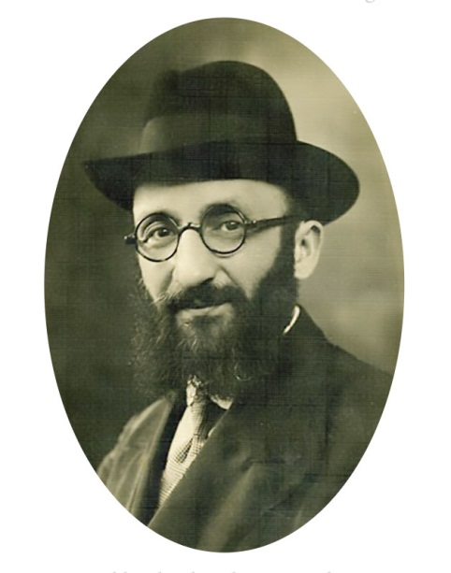

In Bnei Brak’s Bartenura Square, which is located at the foot of the Ponovezh Yeshiva, there was an old kiosk where cups of milk were sold to Yeshiva students. In his ledger, the owner of the kiosk would record the debts of the bachurim (students) as the accrued. Many of the bachurim paid off their debts every few months, with the agreement of the owner.
One Friday, a throng of yeshiva students was seen streaming toward the kiosk, all of them eager to pay their debts. This was an unprecedented occurrence. A rumor spread in the Yeshiva that the currency was about to be devalued. The bachurim wanted to take advantage of the opportunity to rid themselves of the funds they had in the old currency, so that they wouldn’t have to pay the debt according to new currency rates.
The owner of the kiosk arrived at the Yeshiva and complained to Rabbi Eliyahu Dessler, ZT”L, that he had performed a service to the bachurim by extending credit to them for months at a time, but now the bachurim were passing off their old currency onto him to spare themselves the loss they’d sustain as a result of the upcoming currency devaluation.
When Rav Dessler heard about this, he devoted his usual Friday night discourse to the topic of honesty and integrity, teaching his students to be givers, not takers, and if one acts honestly, Hashem will make sure no losses would be incurred as a result (Story from the Aleinu L’shabeach).

Reprinted from the Parshas Naso 5781 email of Torah Sweets Weekly (edited by Mendel Berlin).

Rav Moshe and the Ridiculous Question
By Rabbi Shmuel Choueka

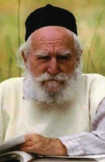

A story is told of a group of mischievous boys who decided to make some prank phone calls to various Rabbis. One of the boys was given the “assignment” to call Rav Moshe Feinstein very late at night and to ask him a totally ridiculous halachah question.
When he called Rav Moshe in the middle of the night and woke him up, he asked his question expecting the Rabbi to get annoyed and simply hang up. But instead, Rav Moshe calmly answered the question, and then started a conversation with the boy.
He asked him what school he was in and which Gemara he was learning. When the boy mentioned that he wasn’t doing so well in school, Rav Moshe stayed on the phone with him and reviewed the Gemara with him, explaining it to him from beginning to end until he fully understood it.
Rav Moshe then gave encouragement to the boy and told him, “I am going to tell you a very strong question that was asked on this Gemara, and I’m going to give you the answer. Tomorrow I want you to ask your Rebbe this question, and if he doesn’t know the answer, you can tell him the answer that I told you.”
The next day, the boy asked the question and his Rebbe was amazed that this student, who never even participated in class, was now asking such a powerful question. When the boy then said the answer to the question, the Rebbe began to see him in a different light and gave him encouragement to put more effort in his learning. In the end, the boy became one of the top students in the class.
And this all came about because Rav Moshe treated him with patience and dignity. This was a true kidush Hashem. Instead of reacting harshly when the boy woke him up and asked him a silly question, he succeeded in turning the boy around simply by showing him respect and speaking kindly to him.
While we are not on the level of Rav Moshe, we all have opportunities to bring glory to Hashem’s name. If we study Torah and do misvot, we are often viewed by others as representatives of the Torah. Our actions are often scrutinized, and any slight misstep can lower the value of Torah study in their eyes. Our behavior is not just a reflection on us, but it is a reflection on the entire Torah and its values.
Whether we like it or not, we are ambassadors of Hashem. We should be conscious of this and do our best to always greet others with a smile and treat them with respect. This will help to sanctify Hashem’s name and bring glory to those who serve Him. May we always succeed in sanctifying Hashem’s name in everything we do.

Reprinted from the Parshat Emor 5781 email of Shabbat Shalom from Cyberspace 5781 (compiled by Rabbi David Bibi).

Mendel the Waiter

Rabbi Norman Lamm tells the amusing story of Mendel the waiter. When the news came through to a cruise liner about the daring Israeli raid on Entebbe in 1976, the passengers wanted to pay tribute, in some way, to Israel and the Jewish people.
A search was undertaken to see if there were any Jewish members on board the ship. Only one Jew could be found: Mendel the waiter. So, at a solemn ceremony, the captain of the cruise liner, on behalf of all the passengers, offered his deep congratulations to Mendel, who suddenly found himself elected de facto as the ambassador of the Jewish people.
We are all, like it or not, ambassadors of the Jewish people, and how we live, behave and treat others reflects not only on us as individuals but on Jewry as a whole, and thus on Judaism and the G-d of Israel.

Reprinted from the Parshat Emor 5781 email of Shabbat Shalom from Cyberspace 5781 (compiled by Rabbi David Bibi).
The Tailor Who Did Not Know He Was Special
By Hillel Baron

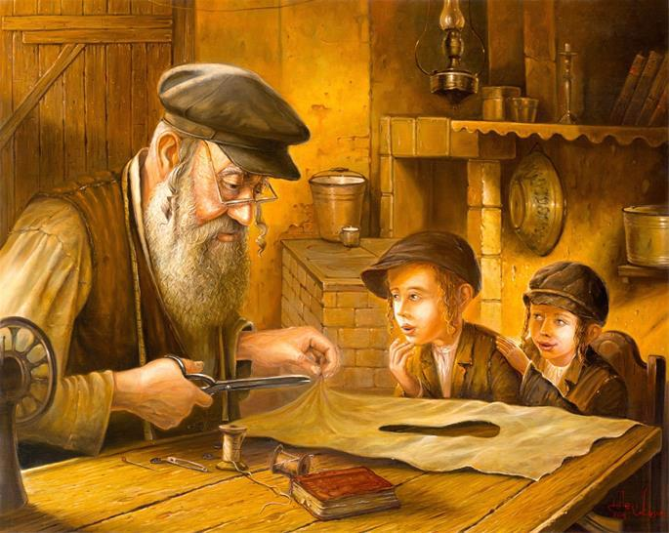
Artwork by Alex Levin
Two simple tailors worked as partners in Vilna. They weren’t making much money in the large city, where there were already many established and well-known tailors around.
They decided to circulate among the small cities of the region to find their luck. With G-d’s help, they were successful, serving simple villagers and peasants.
In one town they passed through, they saw that the Jewish village manager was distraught. He explained that the nobleman, who was the local landowner, would soon be holding a wedding, and had asked the manager to bring the best Jewish tailors to his service. However, the nobleman had not been satisfied with any of the work and was now threatening to fire the manager, and perhaps also expel the Jewish tenants from his properties.

The Two Tailors Ask to Meet the Nobleman
Upon hearing this, the tailors said, “Why don’t you present us to the nobleman?”
“Well,” the manager warily replied, “you aren’t acquainted with high fashion clothing.”
“True,” they replied, “but the nobleman has been dismissing the high fashion, so maybe he’ll appreciate our simpler style.” The manager agreed to give it a shot.
The nobleman asked for a sample dress, and after seeing what they had created, he was thrilled. He contracted them to tailor the wedding clothing for his entire extended family and all of his servants.
After the job was done, they walked away with a hefty sum of money. They also felt good that they had saved the livelihood of the village manager and the Jewish people of the vicinity.

Informed about Plight of the Imprisoned Jewish Inn Keeper
When the tailors were about to leave town, the nobleman’s wife spoke to her husband. “Look,” she said. “We see how these Jews care so much about their co-religionists. Perhaps we should tell them about our Jewish prisoner who couldn't pay the rent for his inn and is still languishing in prison. Maybe these tailors would care enough to pay off his debt and free him.”
She approached the Jewish tailors. When they asked how much the man owed, they were told that he owed 300 rubles. One tailor said that this was too steep a price to pay. The other, however, said, “How can I just walk away from another Jew’s plight?”
He told his partner: “Let us split up our partnership, and see how much each of us truly owns.” It turned out that each was left with precisely the amount needed—300 rubles. The generous tailor immediately gave the money to the nobleman’s wife, and said, “Let the prisoner go free.”
Both tailors returned to Vilna. The one who kept his money was able to establish a professional business in the big city. The other was empty-handed, with no partner, and no cash with which to restart his business. He fell into a deep depression, and the only thing he could manage was to collect donations. He became a beggar, and it seemed to the local population that he had lost his mind.

Very desperate one day, he directly approached a wealthy man, asking him to spare a few coins. The wealthy man asked what he would receive in return, and the beggar answered, “I will pray for you.”
The Beggar Offered to Pray for the Wealthy Man
The wealthy man chuckled, and said: “What will your prayer do for me? But here’s a few coins either way.” The wealthy man went on with his business meetings that day and was very successful. He thought that perhaps it had something to do with the beggar’s blessing.
So the next time he was to have a business meeting, he made a point to pass by the beggar

again. After giving him a few coins, he asked for a blessing. Again, he was fabulously successful with his business affairs.
This went on for quite a few months, until one day, while gathered with family, they asked what was the secret to his newfound, absolute success. He told them about the blessings he made sure to receive, and how they were always fulfilled.
Before long, the erstwhile tailor had a large following of people who would seek his blessings, which consistently came true.
A group of the Baal Shem Tov’s disciples were passing through town and heard the peculiar story of the beggar whose blessings were always fulfilled. They told their master about it, and he said that this must be a very special man, with an especially lofty soul. “Bring him to me,” he said. “I’d like to speak with him.”

The Baalk Shem Tov’s Question to the Beggar
The Baal Shem Tov questioned him, asking what special deeds he had done. The beggar said that he really did not know of any exceptional heroics he could claim. “I’m just a simple man,” he said, “No one unique or important.”
The Baal Shem Tov had the man tell his entire life story. When he reached the part where he parted with 300 rubles to save a man from prison, the Baal Shem Tov exclaimed, “Aha! This is it! This eminent and selfless action of yours is what causes your blessings to come true.”
Hearing this from the Baal Shem Tov, and realizing the uniqueness of his act, left a great impression on the man, and he was able to crawl out of his depression.
The Baal Shem Tov spent time with the sincere tailor and taught him Torah. Eventually, he became an accomplished scholar and a great tzaddik.

Have we had opportunities to effect profound positive change in another’s life? When have we done so? Can we help ourselves and others appreciate the good we have caused—as the Baal Shem Tov did?

Reprinted from the Parshat Behaalotecha 5781 email of Chabad.Org Magazine. (Adapted from The Storyteller, vol. 5, pg. 145)
Celebrating Shabbat at the
Highway 6 Gas Station

Highway 6, also known as Trans-Israel Highway and Cross-Israel Highway, and officially titled Yitzhak Rabin Highway, stretches 138 kilometers from the north to the south of Israel (photo credit: Moshe Shai/Flash90)

There is a great story in Chaim Walder’s People Speak 12 about a family that found itself stuck at a gas station over Shabbat and managed to unite Jewish people from all walks of life. A young rabbi, his wife and kids decided to travel from Ma’alot Tarshiha to his mom’s house in Ashkelon for Shabbat. His sister and her husband asked to come with him, so he borrowed a friend’s car to fit everyone. It was a two-hour trip to Ashkelon, and they left four hours before Shabbat, thinking that was plenty of time. Big mistake!
The car stalled about an hour into the trip. The rabbi and his brother in-law had no knowledge of mechanics. He called a few garages, and they all said they’ll be there soon. When no one showed up, he flagged down a car who stopped to help. The driver offered assistance, and he replaced one of the spark plugs. The car started, and they continued on their way.
The Car Stalled Again on Highway 6
When they pulled onto Highway 6, the car stalled again. A telephone in the emergency Highway box rang, and the operator said, “We see from the cameras that you pulled over; we’re sending you a service vehicle.” Ten minutes later, it arrived. “A plug went,” the mechanic said. “I just replaced one twenty minutes ago,” said the rabbi. “Another must have burned out,” the mechanic clarified. He replaced another spark plug, and the family resumed their journey, hoping to arrive in Ashkelon before Shabbat.
All hope was lost when the car stalled again. Another mechanic was dispatched, and the rabbi asked the mechanic to follow him while he pulls over and into a gas station. They somehow manage to crawl there before the car sputtered and died for the fourth time that day. With eight minutes until sunset, suddenly it hit him. The rabbi, his wife, his two young children, his brother in-law, and sister were all going to spend Shabbat in a gas station on Highway 6!
He quickly ran into the convenience store and bought packaged rolls and snacks. As it grew darker, more and more people started to approach the car. “Hey, you’re religious. Why are you here?” “Our car died,” the rabbi said. “We’re having Shabbat at this gas station.” “Oh no, please let me give you all a lift,” countless people offered. The rabbi looked at his family, “Thank you. But it’s Shabbat, we can’t travel.”

The Non-Secular Jews Joined the
Rabbi in Singing “Lecha Dodi”
People found it hard to leave the gas station and a crowd started to form. The rabbi went up to them and asked, “Want to help me?” Everyone said, “Sure! Whatever you need, let us bring you home!” “No, no not that. Please join me for a minyan.” And so, in the middle of nowhere, at a gas station on Highway 6, a group of unrelated, mismatched Jews start to sing Lecha Dodi.
The rabbi was so touched, he started to cry uncontrollably. They prayed arvit together, said Shabbat Shalom, and the rabbi invited people to join the seudah on a stone table. He made kiddush on a bottle of coke and handed everyone a small piece of a roll with chips and pretzels.
Other Jewish people stopped at the gas station and they all had suggestions: “I have an Arab friend who can take you home.” “Come have your Shabbat at my house, it’s only ten minutes away.” But the rabbi gently reminded them he can’t travel on Shabbat, and he offered for them to come sit with their happy group.
The rabbi started to give a Devar Torah. It was a scene beyond belief. Thirty random Jewish people sat with the charedi family and enjoyed Shabbat together with food and Torah. All of them asked for the rabbi’s phone number so they can check on the family after Shabbat was over. He gave his name but not his phone number, afraid they would write it down. “Call information after Shabbat and give me a call!”

The Night Became Really Cold
The singing ended, night fell, and it started to get really cold. The rabbi said to his wife, “You and my sister stay in the car with the children, and my brother in-law and I will sleep on the benches.” At this time, people milled around the station to fill their tanks. Hundreds of Jews passed through the station, approached the family that was stuck, and offered help.
The rabbi and his brother in-law fall asleep on the benches, unaware that cold temperatures can be extremely dangerous. At midnight, they were so weak from their freezing state, and they heard some voices. A few buses carrying fans of rival soccer teams heading home from a game stopped at the gas station on Highway 6.
“Let’s cover them so they don’t freeze to death!” One after the other, they removed their team scarves, red and yellow, and placed them on top of the rabbi and his brother in-law. Dozens of scarves covered them, and their temperatures slowly rose back to normal.

The Rabbi’s Plight United Rival Soccer Fans
When he came to, the rabbi held the makeshift blanket and asked, “Where did these come from?” One of the soccer fans crouched down, “Achi—my brother, we are fans of two rival teams. Enemies. During a game, they need policemen and armed security guards to keep us apart. But we heard what you people did here for Shabbat, and look, here are scarves in both colors. We’re here together to warm you up. Come dance, so you can bring your temperature back up.”
Hundreds of fans gathered in a circle and danced with the rabbi and his brother in-law, while the women and children looked on in wonder. The next day, more people came to the station with ideas, and the rabbi asked again for a minyan.
Motzei Shabbat arrived, and with it, hundreds of calls to the rabbi’s phone to see how the rest of Shabbat went. Most of the people who called said they decided to keep that Shabbat, a first in many years.
Five years later, the rabbi is still in contact with dozens of people he met at the gas station, with a dozen now fully keeping Shabbat. He is now known as the Rabbi of Highway 6, and he is incredibly grateful for being able to experience a Shabbat with Am Yisrael, who went above and beyond, and who forgot all their disputes, uniting to help a stranded family.

Reprinted from the Parshat Bamidbar 5781 email of Jack E. Rahmey based on the teachings of Rabbi Amram Sananes.

